
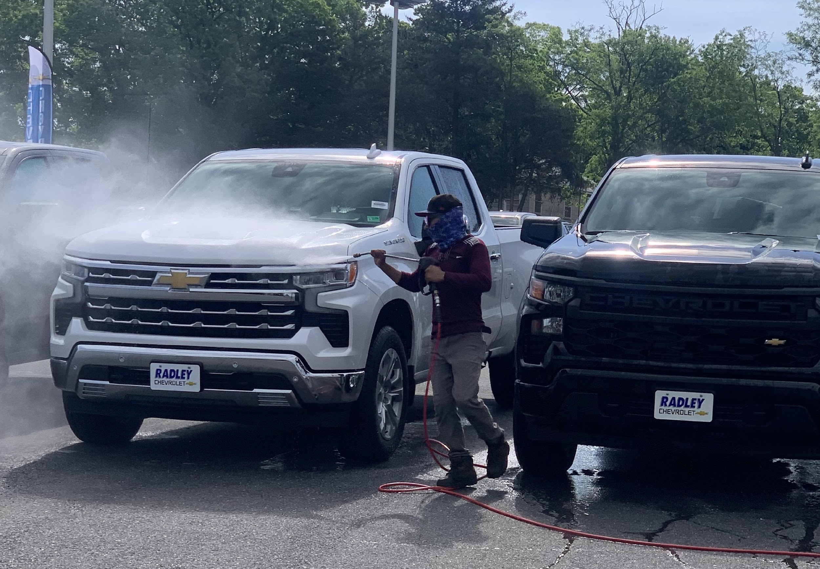
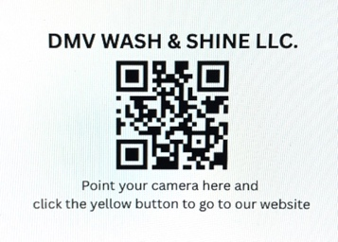

6315 Phyllis Ln. Alexandria, VA 22312
Phone: (571) - 249 - 6119
Email: tuando@DMVwashshine.com
Website: www.dmvwashshine.com Alexandria, ______________________

CONTACT INFORMATION & AGREEMENTS

Warmest greetings to you and your family!

On behalf of DMV Wash & Shine LLC., we would like to ask you for some information and provide you with the agreements between DMV Wash & Shine LLC. and your company in this form below.

- Price: $ ___________ per car wash (new car or used car)
- Location to wash: ___________________________________________________
- How many times to wash: Weekly: ____________ Monthly: ___________
- Date to start: _______________ Date to end: _________________
- Where to send invoice to: ___________________________________________
- Please send payment to: DMV Wash & Shine LLC.
- Accountant information: Name: ________________ Email: ______________________
Phone: _______________ Cell: _______________
8. Manager information: Name: ________________ Email: ______________________
Phone: _______________ Cell: _______________

We do appreciate your partnership. Please don't hesitate to contact me at: (571) 249-6119 (Cell)

May God bless you, your family and your business abundantly.

Respectfully yours, Your Company Manager’s Signature

_____________________ Date: ___________
Tuan Do
Manager at DMV Wash & Shine LLC. Full Name: ____________________________

